Brachycephalic Ocular Syndrome (BOS) in Dogs

What is Brachycephalic Ocular Syndrome (BOS)?

Brachycephalic Ocular Syndrome (BOS) refers to a group of eye problems commonly seen in dogs with brachycephalic (short-nosed) skull shapes, such as Bulldogs, Pugs, Shih Tzus, and French Bulldogs. These breeds have anatomical features that make them look very appealing to us but also makes them more prone to eye conditions that could affect their comfort and vision.

Causes of BOS

Brachycephalic breeds have flattened facial structures that result in anatomical changes that predispose them to a variety of eye problems. Key factors contributing to BOS include:

Shallow eye sockets (orbits): In brachycephalic dogs, the eye sockets are often too shallow, leading to exposure of the cornea and making the eye more vulnerable to dryness and injury.

Eyelid abnormalities: These dogs may have large eyelid openings, which can lead to problems such as entropion (inward rolling of the eyelids) or lagophthalmos (inability to fully close the eyelids).

Proptosis: The position of the eye in brachycephalic dogs makes it more likely for the eye to pop out of the socket if the dog experiences trauma or excessive pressure.

Corneal exposure: The shallow eye sockets and abnormal eyelid function result in less protection for the cornea, leading to dryness, irritation, and sometimes ulcers.

As a result, BOS includes a range of potential eye problems that often occur together, and managing them early can help prevent serious complications like vision loss.

Common Eye Conditions Associated with BOS

Dry Eye (Keratoconjunctivitis Sicca): Due to poor eyelid closure and corneal exposure, these dogs often develop reduced tear production and / or poor tear quality, leading to dry, irritated eyes.

Entropion: The inward rolling of the eyelids at the inner corner, causing the lashes to rub against the surface of the eye, can lead to irritation, scarring (pigmentary keratitis) and potentially corneal ulcers.

Pigmentary keratitis: Chronic irritation at the inner medial canthus can lead to dark pigment accululating on the inner cornea, which can spread across the cornea, leading to blindness.

Corneal Ulcers: Shallow eye sockets and poor eyelid function increase the risk of corneal ulcers, which are painful and can cause scarring, vision problems or eye loss if left untreated or if treatment is unsuccessful.

Cherry Eye: A prolapse of the third eyelid gland that is common in brachycephalic breeds, which can cause swelling and a red, bulging mass in the eye. This not normal and needs surgical correction.

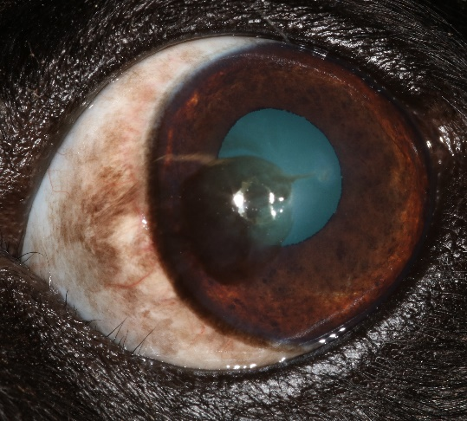
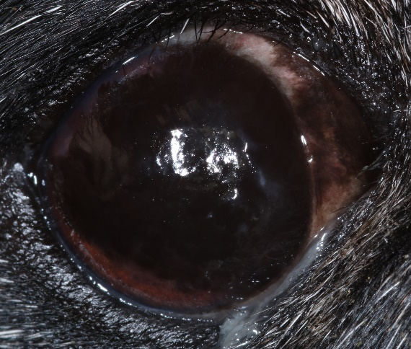

Advanced pigmentary keratitis
Early pigmentary keratitis

Treatment of BOS

Treatment for Brachycephalic Ocular Syndrome typically focuses on managing symptoms and preventing complications. Options may include:

1. Medications:

Eye drops that can be used include artificial tears to lubricate (longterm), immunosuppressant ointment to improve the tear film (longterm) and anti-inflammatory or antibiotic drops when indicated.

2. Surgical Treatments:

In more severe cases or if there is ongoing irritation, surgery may be required to correct certain anatomical issues:

• Medial canthoplasty surgery involves removing the inner corner of the upper and lower eyelids. The skin is closed leading to smaller eyelid opening. The eyelids are then in a better anatomical position allowing more protection of the eye, improved tear film because of reduced evaporation, elimination of entropion and therefore reduction in progression of pigmentary keratitis. Corneal ulceration and proptosis risk are therefore reduced. This can be combined with a surgical facial fold resection in some cases.

3. Lifestyle and Environmental Modifications:

The eyes should be kept moist with lubricating eye drops at least, and also medicated eye drops if indicated. They could be protected with specially designed dog eye-wear in a few cases. Excessive body weight should be avoided. Lead attachment to a harness is recommended to reduce pressure on the neck and therefore the eyes. Avoid situations like rough play. Early diagnosis and treatment are key to preventing more serious complications, so go to your vet early if you see any eye changes or possible discomfort.

