Corneal Sequestrum in Cats

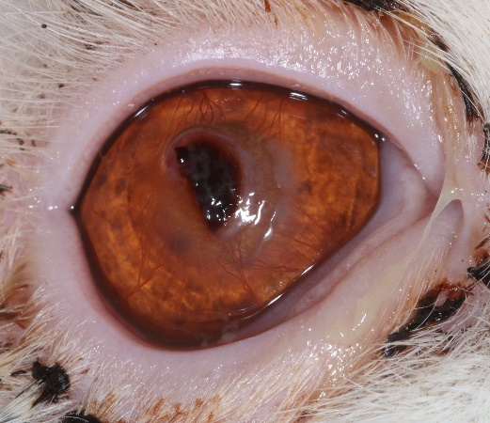

What is Corneal Sequestrum?

Corneal sequestrum occurs when a portion of the cornea (the clear, outer surface that covers the front of the eye) becomes necrotic, or dead. This condition appears as a dark, brownish-black area in the cornea and can cause pain, discomfort, and potential vision issues.

Causes and Risk Factors

Chronic Eye Irritation: Often caused by conditions such as eyelid entropion, keratitis, or corneal ulcers that do not heal properly.

Breed Predisposition: Certain breeds, such as Persians, Himalayans, and other brachycephalic (short-nosed) cats, are more susceptible due to their eye shape and frequent tear film issues. Any breed can be affected however.

Injury or Trauma: Any damage the cornea can lead to sequestrum formation.

Underlying Health Issues: Cats with poor tear production or chronic herpesvirus are more prone to developing this problem.

Treatment Options

Conservative Management: If the sequestrum is small, superficial and not causing obvious discomfort, treatment may involve topical antibiotic and occasionally anti-inflammatory eye drops. However cats can internalise discomfort so we can find this difficult to judge. The sequestrum might slowly lift from the cornea itself, a process that usually takes many months. Occasionally the sequestrum deepens instead though, leading to perforation of the cornea and rupture of the eye, requiring enucleation (eye removal) surgery.

Surgical Intervention: For larger or more painful sequestrum, surgery may be required. The dead tissue is precisely removed under general anaesthetic using an operating microscope (keratectomy). A corneal flap / graft may be required to fill the defect. They can heal really well although some monitoring is required in the recovery period. Surgery provides the most prompt resolution of the problem which could otherwise be present for many months, and is preferred in many cases.

Post-Operative Care: This may include follow-up appointments and medications such as topical ointments or drops to support healing. A buster collar is required for 7-10 days.

What is the liklihood of recurrence?

It is possible that another sequestrum will develop but most cats heal well without recurrence. Another sequestrum can develop, in days, months or years, and it cannot be predicted. If it does recur, further surgery will be recommended.

