Neurogenic Dry Eye in Dogs

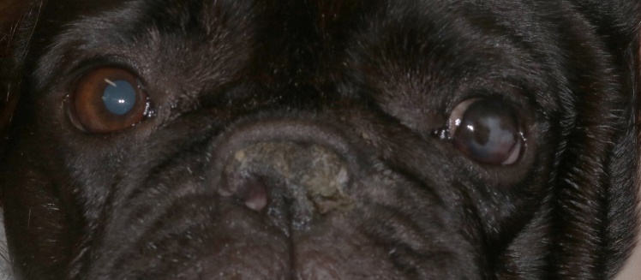
What is Neurogenic Dry Eye?
Neurogenic Dry Eye occurs when there is damage to the parasympathjetic portion of facial nerve which is responsible for stimulating tear glands and nasal mucosal glands to produce moisture. Without adequate moisture production, the eye can become suddenly and profoundly dry, irritated, and prone to ulceration (typically affecting one side only, with the nostril on the same side usually dry also). Sometimes a cause is known such as an ear infection or ear treatments, but more commonly the condition can develop spontaneously (termed idiopathic). Neurogenic dry eye is less common than other forms of dry eye.
.

Example of a dog with left-sided neurogenic dry eye with crusting and dryness of the nostril on the same side.

Treatment for Neurogenic Dry Eye

The goal of treatment for neurogenic dry eye is to improve tear production, relieve discomfort, and prevent further damage to the eye. Since the condition is caused by nerve damage, it is typically managed rather than cured. Treatment options include:

1. Artificial Tears
- Lubricating eye drops or ointments are commonly used to provide moisture to the eye and relieve irritation. These should be applied frequently, especially if your dog is showing signs of discomfort.
2. Immunosuppressant ointment
- This medication (for example Optimmune) is used to stimulate tear production in dogs with dry eye. It may take several weeks to see improvement. It isn’t always prescribed with neurogenic dry eye.
3. Oral tear stimulants
- In certain cases, your ophthalmologist will prescribe an eye drop called pilocarpine that is administered orally in food. This drop works on various organs such as the gut, but also on the tear gland directly stimulating tear production. We start with a low dose and usually slowly increase, reducing if side effects develop such as stomach upset or nausea.
4. Antibiotics or pain relief
- Other medications are supplied on a case by case basis as needed.

Prognosis
The prognosis for neurogenic dry eye depends on the severity of the nerve damage and how well your dog responds to treatment. Some cases resolve fully and others are very difficult to manage and can require eye removal to manage the pain.

